**5006 lab 1**

Task 1

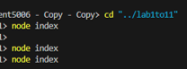



This is task one, here I have saved my index.js file in a folder on my desktop and insured it knew the directory of my file by using “cd lab1to11” code in terminal. Then ran the code using “node index” to display the desired output.

Task 2

Here I used the provided code and add it into my index.js file then run “node index.js” again to get an output of “the sum of 5 and 3 is: 8”.

Task 3

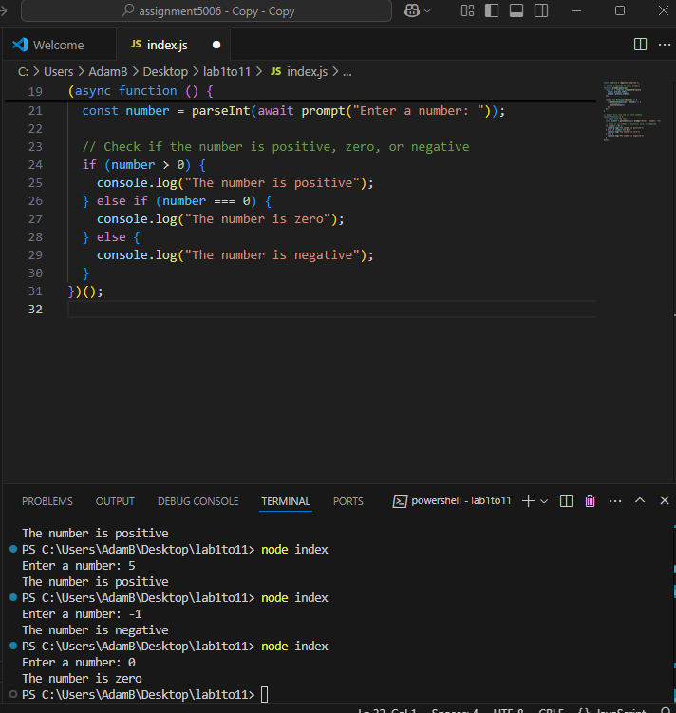

This is task3 here I entered the provided code into my Index.js file. This then allows the user to enter an input, and based on it returns a statement. In this case it is whether number is “positive”, “zero”, or “negative”.

Task 4

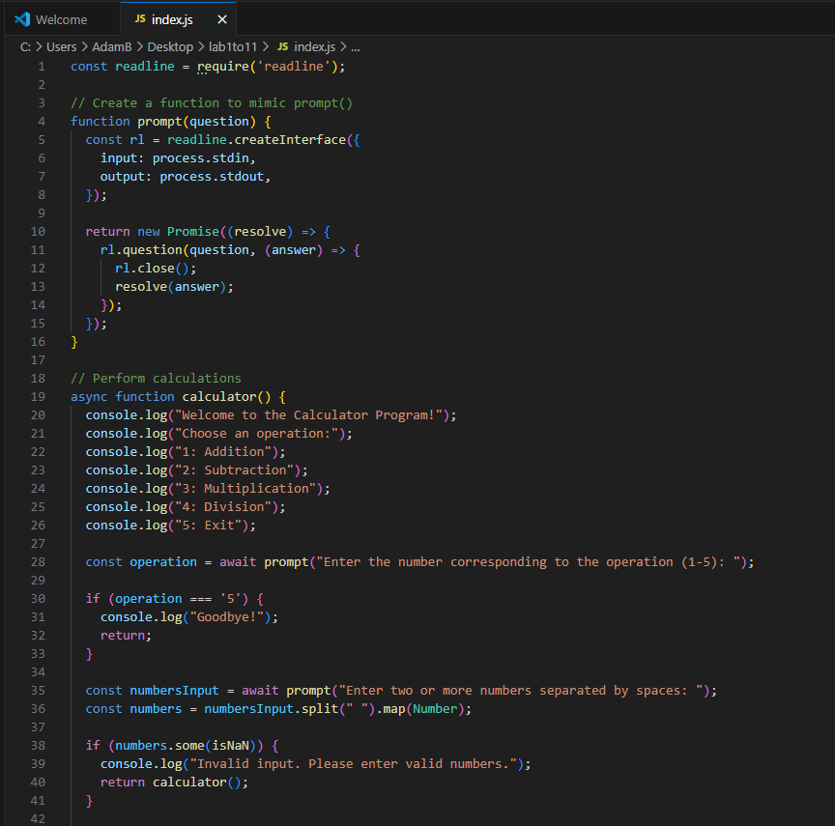

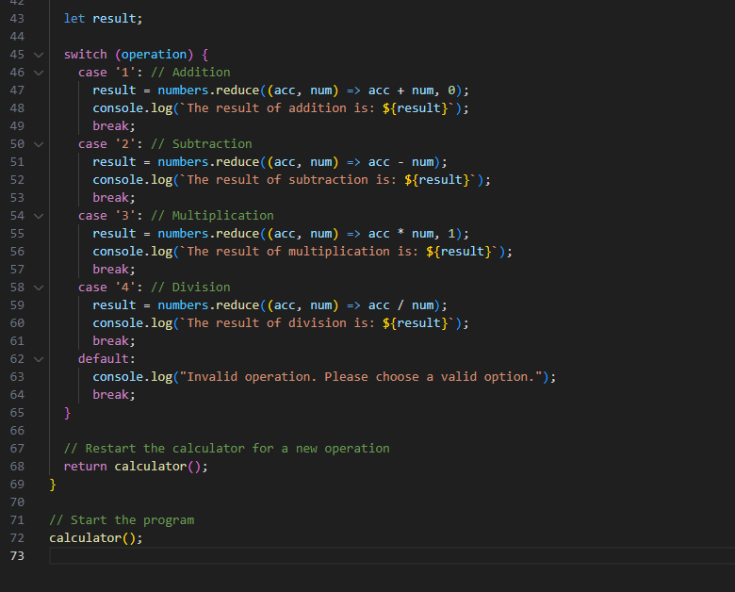

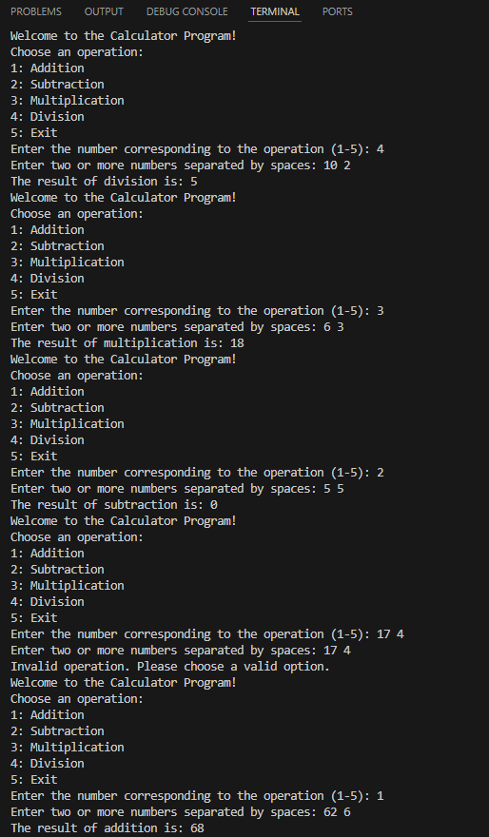

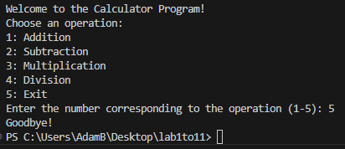

This program uses a switch statement to determine which calculation to perform based on the user's input. The break keyword is used in each case to halt further execution once the chosen operation is completed. A list of operations (addition, subtraction, multiplication, and division) is displayed at the start, allowing the user to easily select the desired action. The return statement is used to exit the current function or restart the calculator for another calculation. All of my programs handle user input and display results using a general prompt like "node index," rather than a specific prompt that changes with the code.